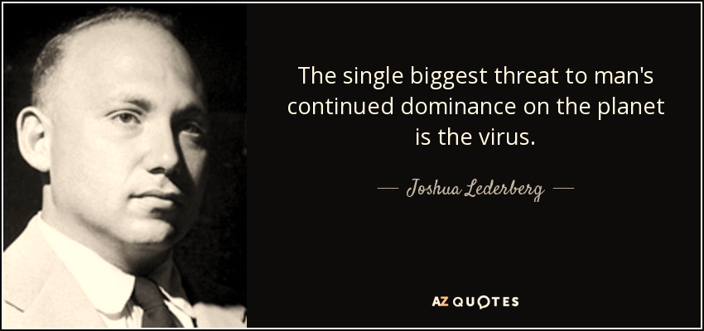

Source: Web

**Category**

Forward**1**

Virus Infection vs. Immune System**2**

How Scary Are Viruses?**6**

Treatment for Virus Infection**13**

Virus Disease: Prevention and Preparation**16**

**Forward**

Virus infection is a topic that is never out of date. Most of us have protected ourselves well against one and another outbreak of virus epidemic worldwide, but we may never realize that how scary viruses are.

Here we prepared a detailed guide on virus to help you, whether have been infected yet or not, to learn more about the scary “thing” and your body for now and future.

(Forward by Kyrie)

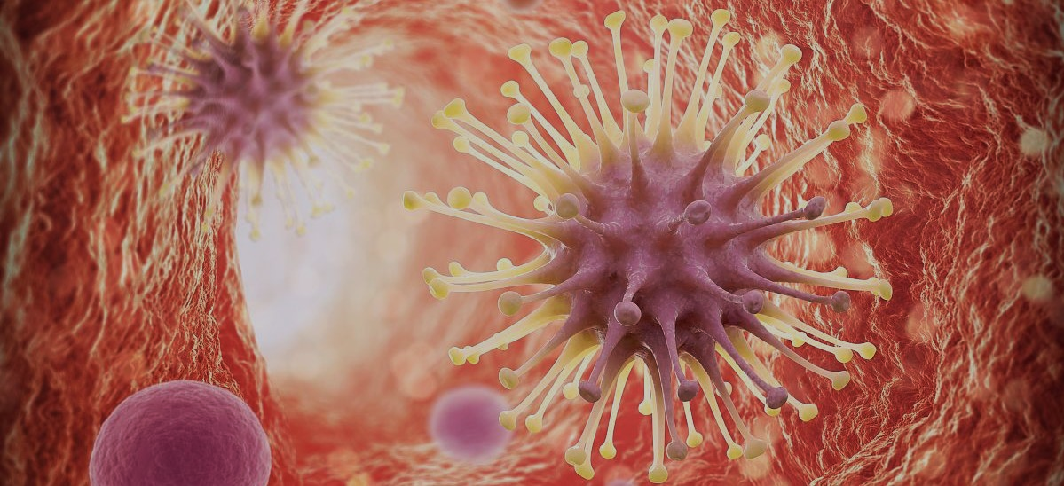

Virus Infection

vs.

Immune System

(By Lebron)

Source: www.vcg.com

* **How do virus particles infect our body?**

The picture on the next page describes a typical way

of virus infection.

* **Virus infection**

Virus infection is the process of invasion and propagation of harmful viruses in the body of humans, animals, plants, or microorganisms, which mainly contains **introducing their genetic information into a cell** and **forcing the cell to replicate more virus particles** by using the cell’s internal machinery. [1]

* The first and the second step of virus infection is invading into a host cell, during which, the virions adsorb on the cytomembrane and inject their nucleic acid (take RNA virus as an example) and some special proteins into the nucleus of the host cell.
* When these RNAs and proteins get to the right place, RNAs begin to make **self-replication** (3a in the picture) and **transcription** (3b in the picture) into mRNAs.
* These mRNAs are free in cytoplasm and force the ribosomes (4 in the picture) in the host cell to produce proteins (5a and 5b in the picture) as a basic component of virus particles. Those RNAs and proteins can combine and become a newly-formed virion.

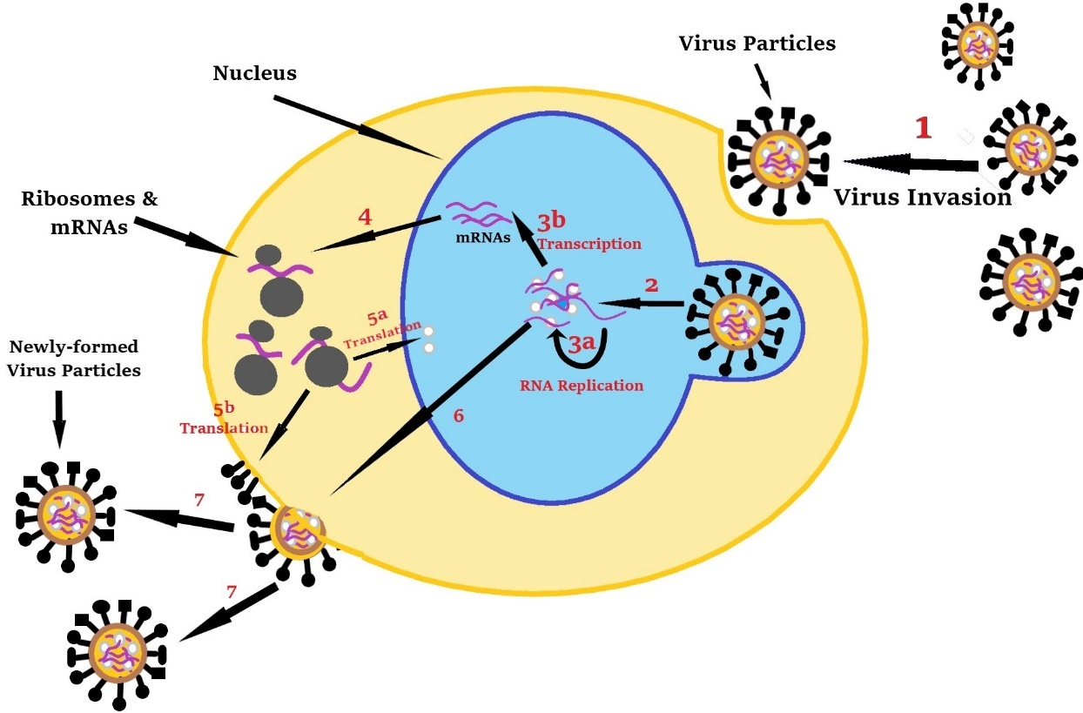

Picture made by Lebron

After making enough copies, the host cell will burst into pieces and newly-formed viruses are free to invade other cells.

* **Immune system**

Immune system guarantees the safety during the viral invasion, which will produce anti-viral molecules to stop the replication of virus particles. In humans or other mammals, the immune system contains two main subsystems, called **humoral immunity** and **cellular immunity**.

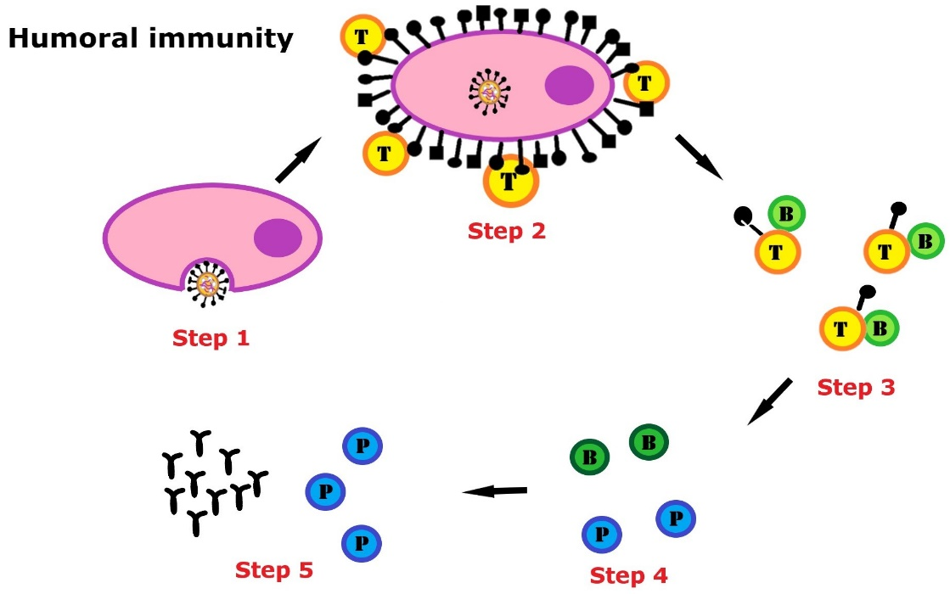

Picture made by Lebron

* **Humoral immunity**

Humoral immunity, according to The American Heritage Medical Dictionary, “involves the transformation of B-lymphocytes into plasma

cells that produce and secrete antibodies to a specific antigen.” [2] Humoral immunity often contains five steps which are displayed in the picture above.

① the pathogen is engulfed by a macrophage.

② the pathogen is ‘digested’ by the macrophage and its antigen is given to some T helper cells.

③ the active T helper cell show the specific antigen to a B cell which is activated after receiving the ‘message’.

④ some of the active B cells become plasma cells free in body fluid while others turn into memory B cells preparing for the second virus infection.

⑤ a large sum of antibodies is produced and secreted by plasma cells which can fight against the specific antigen. [3]

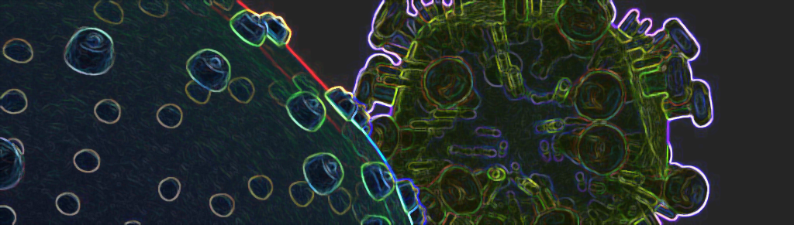

* **Cellular immunity**

Cellular immunity, according to Medical Dictionary for the Health Professions and Nursing, “is initiated by T lymphocytes and mediated by T lymphocytes, macrophages, or both.” [4]

Picture source:www.quanjing.com

* **A New Way of HIV Infection**

Recently, on April 17,2018, scientists in Trinity College Dublin found a new way that HIV avoids the elimination of the immune system and infects human body. A powerful anti-viral molecule called Interferon, which mostly interferes the self-replication of virions and greatly decrease the number of the newly formed virus, will be produced by the immune system whenever virus infection occurs. However, according to the ScienceDaily, HIV contributes to the destruction of Interferon signaling pathway. As a result, the production of anti-viral molecules is reduced and the immune system is not able to eliminate HIV virus.

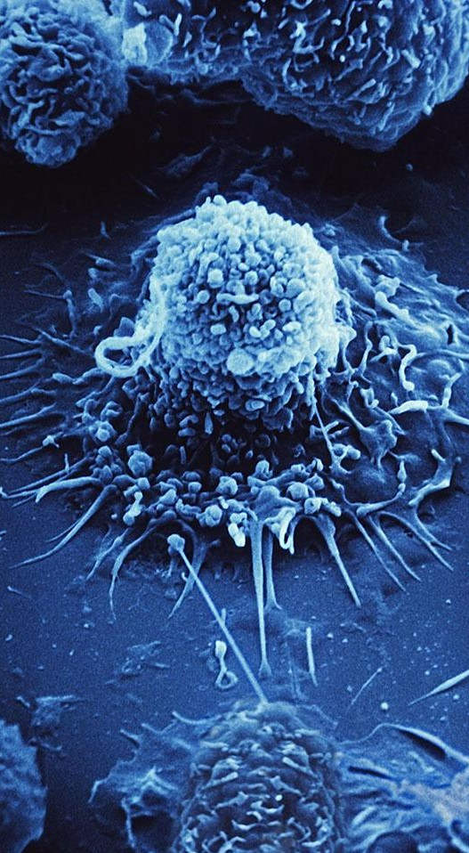

* **Reference**

[1] Koonin EV, Senkevich TG, Dolja VV. The ancient Virus World and evolution of cells. Biology Direct. 2006;1:29. doi:10.1186/1745-6150-1-29. PMID 16984643.

[2] The American Heritage® Medical Dictionary Copyright © 2007, 2004 by Houghton Mifflin Company. Published by Houghton Mifflin Company.

[3] Boundless (2016-05-26). "Humoral Immune Response". Boundless.

[4] Medical Dictionary for the Health Professions and Nursing © Farlex 2012

[5] Trinity College Dublin. (2018, April 17). New way that HIV evades the immune system. ScienceDaily. Retrieved June 20, 2018 from www.sciencedaily.com/releases/2018/04/180417115716.htm

Since HIV can avoid the elimination of the immune system and continue to evade other healthy cells, this kind of scaring virus is not curable up to now. [5]

Picture source:www.quanjing.com

[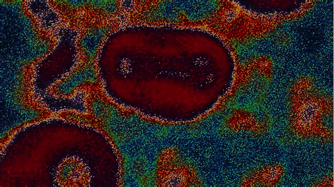](http://cn.bing.com/images/search?view=detailV2&ccid=3SRYLKXu&id=91D382ABFD3BF4E2D248B87BF292CD770BCAB81A&thid=OIP.3SRYLKXuQzKQFSii8IKeuAHaEK&mediaurl=https://media2.s-nbcnews.com/i/MSNBC/Components/Video/__NEW/nn_04_nsn_smallpox_140708.jpg&exph=1080&expw=1920&q=small+pox+virus&simid=608032861694593330&selectedIndex=15)How scary

are viruses?

It is academically defined that how scary a virus is

using Biohazard Level from level 1 to level 4.

However, we could define the scariest biological virus in a

more understandable way using the following four criteria. (By Kyrie)

* **Fatality Rate**

The higher fatality rate the virus has, the bigger chance you will die once you are infected.

* **Virus Latency**

It means the lasting time from when you are infected by virus and when the doctor can detect the clinical symptom. It is also an important factor because if the latency is long enough, this virus might infect a larger scale of people, even the whole human being.

* **Infectivity**

If a virus has too many kinds of transmission channels, like sweat, saliva, body fluids, droplets, it increases the difficulty to guard ourselves against its spread.

* **Cure Rate**

Cure is not too late a way to fight against viruses. However, the most common “medicine” we use is vaccine.

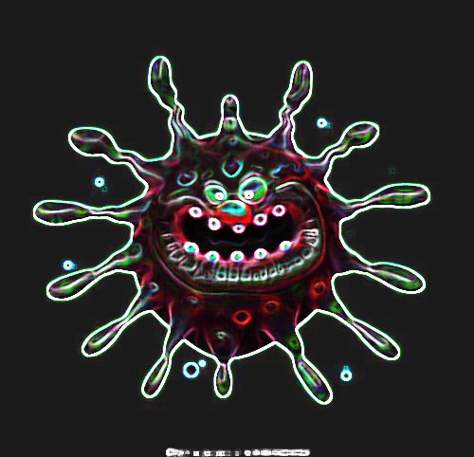

Assume that there is a virus performing very “excellent” in the aspects above, which has a fatality rating up to 100%, long latency and hard to detect, easiest way to transmit, and cannot be cured for a long time, then it may wipe out all human beings.

Fortunately, viruses like this have not emerged in human history, but we humans are always at disadvantage in fight of viruses and viruses that caused national or world’s health crisis do exist. We list three most feared viruses known so far to detailly show its power.

Note: Degree increases from “★” (lowest level) to “★★★★★” (highest level).

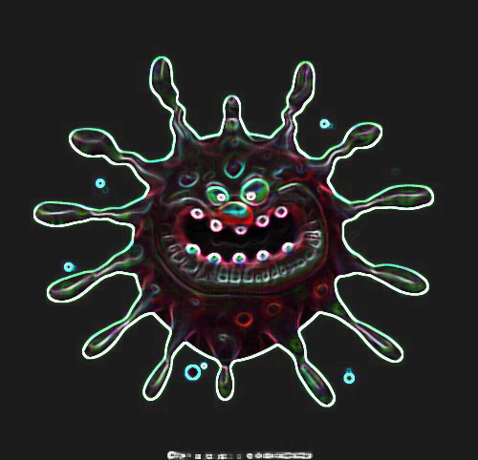

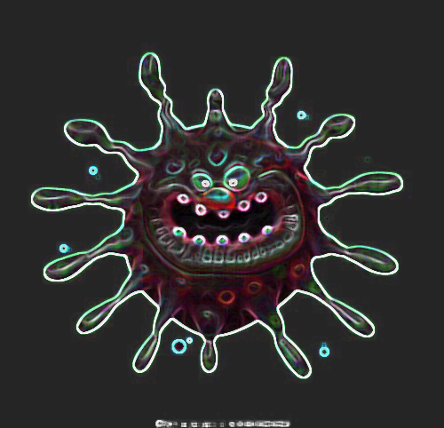

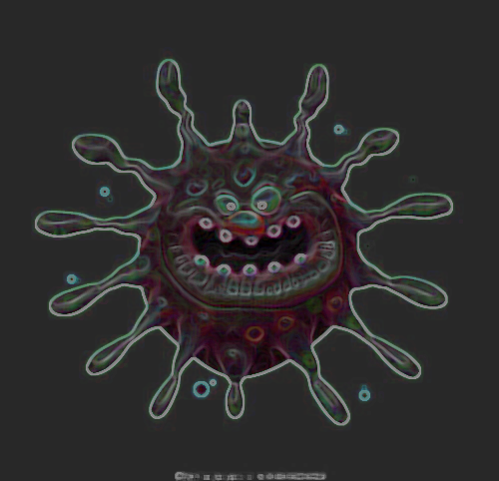Scariest

virus?

Source of pictures: Web

(1)

[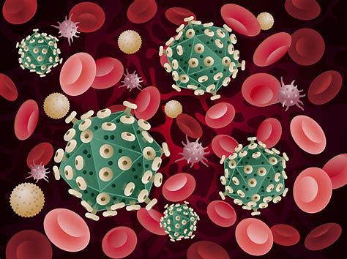](http://cn.bing.com/images/search?view=detailV2&ccid=v1FnsXQn&id=DE03A7D9719AAC96625353329FC486390CEED597&thid=OIP.v1FnsXQnQ8n-Vd7B4OdV1wHaFj&mediaurl=https://www.std-gov.org/images/HIV-AIDS-5.jpg&exph=750&expw=1000&q=hiv&simid=608012396250466546&selectedIndex=33)

**Human immunodeficiency virus (HIV)**

Fatality rate: ★★★★

Virus latency: ★★★★★

Infectivity: ★★

Cure rate: ★

HIV weakens the immune system by infecting certain white blood cells and destroying the body's defenses against infection and disease--the body's immune system. When the immune system becomes weak and vulnerable, the body loses protection against the disease. Over time, the immune system cannot fight HIV infection, and patients may develop serious and fatal diseases, including other types of infections and certain cancers.

There are two types of HIV: HIV-1 and HIV-2, of which HIV-1 is more easily transmitted and more pathogenic. HIV-2 is largely confined to West Africa, Angola, and Mozambique.

Up to now, HIV cannot be cured but can be controlled by an increasingly effective way called combined antiretroviral therapy (cART), which helps extend life spans of a number of patients to a normal level. [1]

Source: Web

(2)

[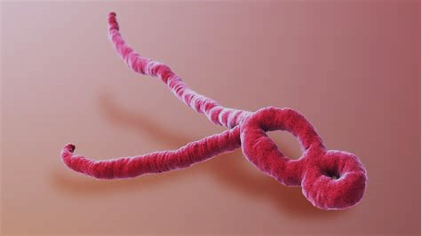](http://cn.bing.com/images/search?view=detailV2&ccid=9Sry3o3P&id=E6521FF91FBF1FFDCD80525EB5F7C43E2CA1DFA6&thid=OIP.9Sry3o3P7sVfEGuWEZLnHAHaEK&mediaurl=https://cdn.zmescience.com/wp-content/uploads/2017/05/SAG_Ebola.jpg&exph=720&expw=1280&q=ebola&simid=608042748713961782&selectedIndex=72)

**Ebola Virus Disease (EVD)**

Fatality rate: ★★★★★

Virus latency: ★★

Infectivity: ★★

Cure rate: ★

Source: Web

Ebola is a rare but deadly disease caused by four of five strains of Ebola viruses. When it enters the body, it kills cells and causes some of them explode. It can destroy the immune system, causing massive bleeding in the body and damage almost all organs.

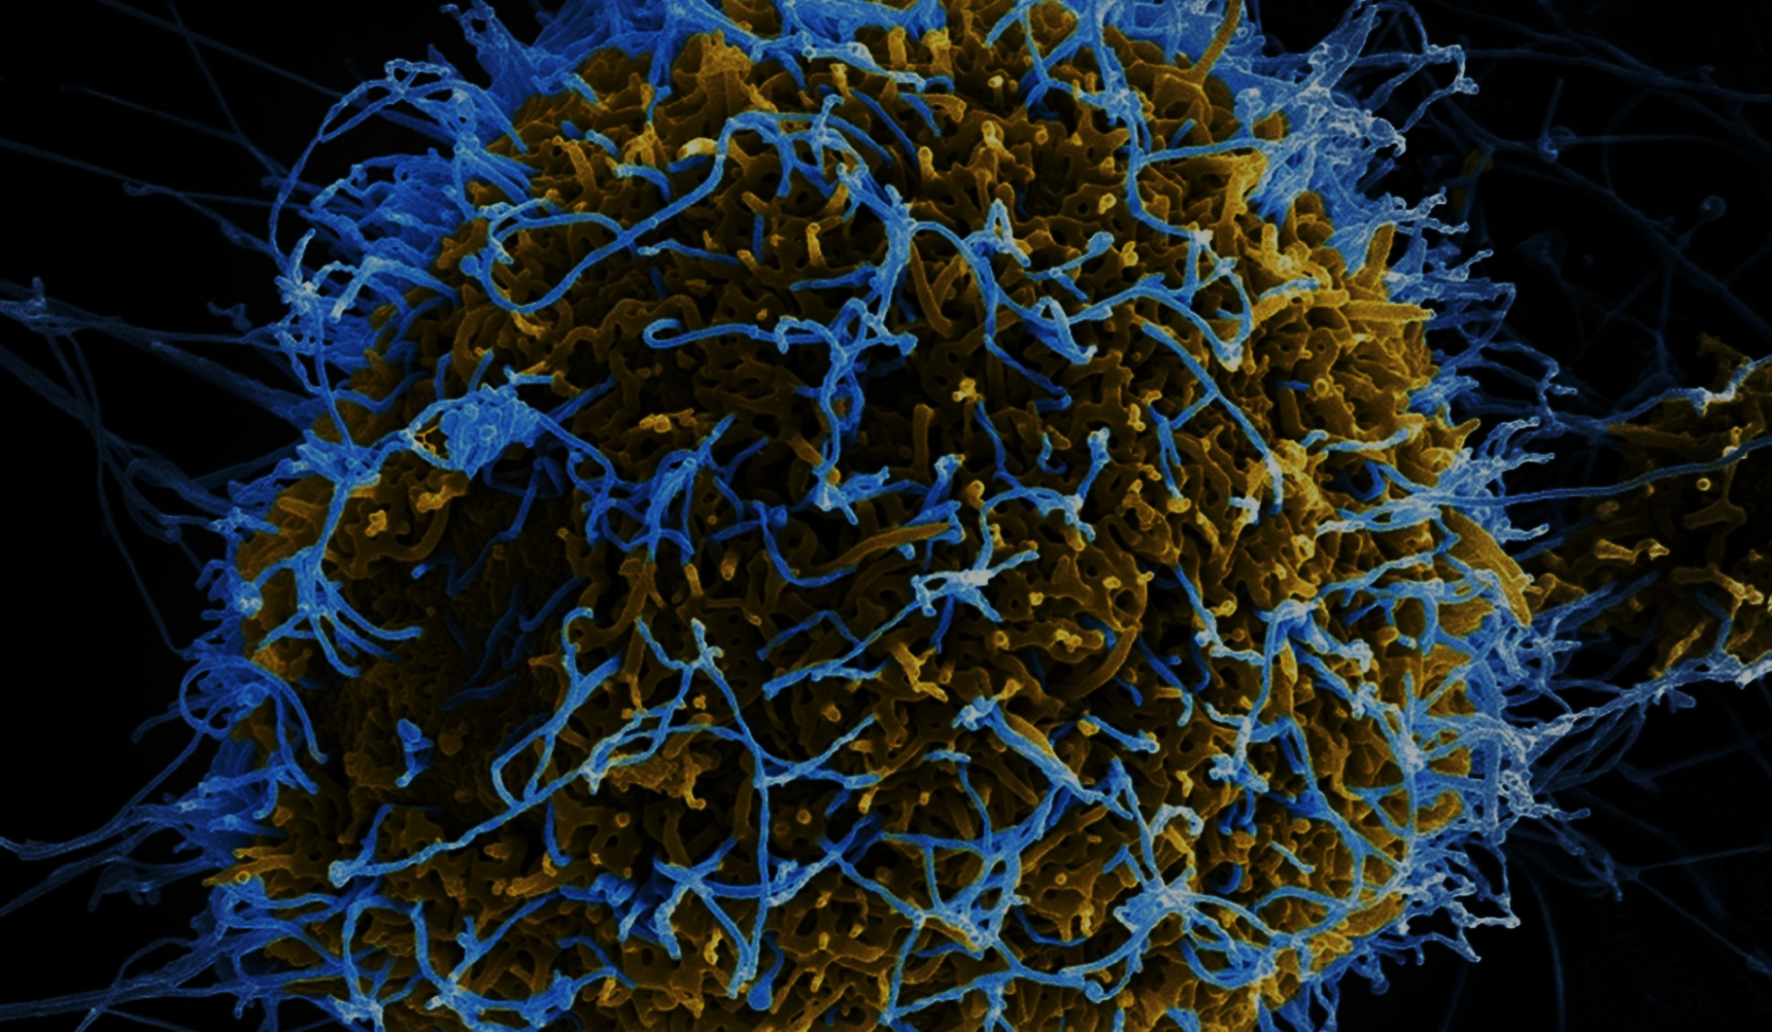

Ebola virus transmits to people through direct contact with the bodily fluids of a person that infected or dead from Ebola or infected animals, like monkeys, fruit bats, and primates. However, onset of this infection is quick and its symptoms are obvious, which mainly perform as high fever, headache, sore throat, or weakness.

Up to now, no cure is available for Ebola, though scientists have been doing researches on curation and vaccine on it.

Ebola has extremely high fatality rate. Up to 90% people who are infected Ebola will be killed. [2]

Here are a picture of Ebola transmission area at the beginning and a comment on the outbreak of Ebola from director of CDC (Centers for Disease Control).

*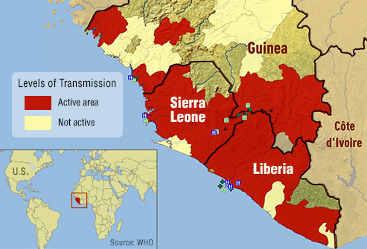“It’s like fighting a forest fire. Leave behind one burning ember and the epidemic could re-ignite. That ember could be one case undetected, one contact not traced or health care worker not effectively protected, or one burial ceremony conducted unsafely.”*

– Dr. Tom Frieden, CDC Director August 20, 2014

(3)

[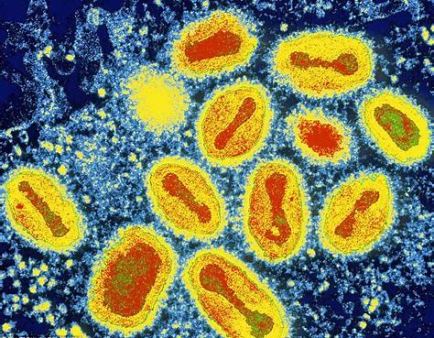](http://cn.bing.com/images/search?view=detailV2&ccid=z8/9msv0&id=E392D32EF21FCCE83F86E75F40D69E864E4D5334&thid=OIP.z8_9msv04wDJaCV_DkaMGQHaF8&mediaurl=http://www.sciencenutshell.com/wp-content/uploads/2015/02/smallpox.jpg&exph=773&expw=964&q=small+pox+virus&simid=608019134976099521&selectedIndex=0)

**Small Pox**

Fatality rate: ★★★★★

Virus latency: ★

Infectivity: ★★★★★

Cure rate: ★★★★★

Source: Web

Small pox is an infectious, disfiguring, and deadly disease that has been raging for thousands of years, but fortunately eradicated worldwide by 1980.

Small pox is caused by variola virus which can be transmitted very easily. Variola virus can infect people by the droplets that infected people cough, sneeze or talks in the air, and via contaminated items used by infected people. So, staying in the place that infected people ever stayed could highly raise the possibility of infection.

Virus latency of small pox is short, usually 10 to 14 days after infection.

There is no cure for small pox. People use vaccine to prevent small pox, though along with high side effects. When infected, treatment can only relieve the symptoms and prevent the patient from dehydrated. [3]

(4)

[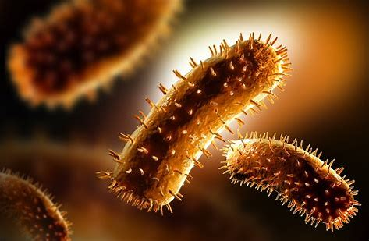](http://cn.bing.com/images/search?view=detailV2&ccid=9C1C7lY9&id=E89C7E43EF098819730E1FA815F1DFC7BE34680D&thid=OIP.9C1C7lY90cpS3yU4b0MhtgHaE1&mediaurl=http://healthfacts.ng/wp-content/uploads/2015/12/rabies-control.jpg&exph=706&expw=1080&q=rabies+virus&simid=608008921583783170&selectedIndex=6)Source of picture: Web

**Rabies**

Fatality rate: ★★★★★

Virus latency: ★★★

Infectivity: ★

Cure rate: ★★★★★

Rabies is a disease caused by rabies virus, which can affect the central nervous system and finally damage the brain and lead to death. According to World Health Organization (WHO), up to 59000 people die of rabies worldwide every year.

99% cases of rabies are due to the bite of a rabid animal like raccoons, skunks, and bats.

The incubation period (the period between bite and onset of symptoms) ranges from several days to 6 years, but usually takes 4 to 12 weeks with symptoms of fever, muscle weakness, and tingling.

Rabies can be preventable but not curable. If bitten by an animal, the person should get a rabies vaccination as soon as possible. The rabies vaccination is now the most effective way to prevent and treat rabies disease. [4]

**Reference:**

[1] Handbook of Clinical Neurology, Chapter 1-Introduction to HIV infection and HIV neurology, Volume 152, 2018, Page 1-2, Bruce James Brew

[2] Centers for Disease Control and Prevention, CDC 24, September, Ebola (Ebola Virus Disease)

[3] Department of Health. Guidelines for smallpox response and management in the post-eradication era 2003

[4] World Health Organization, Rabies, 2018. URL: http://www.who.int/en/news-room/fact-sheets/detail/rabies